**Subversion Logs 11-22-2021 7pm**

Compact Version

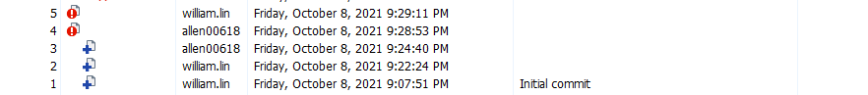

Command Prompt Version

